แบบทดสอบก่อนเรียน

อ่านบทสนทนาหรือเรื่องราวแล้วจัดเรียงลำดับให้ถูกต้อง (ข้อ 1-3)
A : Thanks, you too.
B : Hi, how are you?
C : That’s good idea. And I think I’ll go home and go to bed.
D : Really? That’s too bad. Why don’t you drink some hot tea?
E : I don’t feel very well. I have a terrible stomachache.
F : Yeah. You should get some rest. I hope you feel better.
1. 1) B, E, D, C, F, A 2) B, E, C, D, A, F
3) B, E, D, F, C, A 4) B, E, D, C, A, E
A : She had disappeared in the crowd.
B : I gave her directions and she thanked me politely, then ran off in the opposite direction.
C : The other day when I was shopping, a woman stopped me and asked me the way to the post office.
D : I shouted and ran after her but it was no good.
E : She must have taken it while we were talking.
F : I put my hand in my pocket and found that my wallet was missing.
2. 1) C, B, F, E, D, A 2) C, B, E, F, D, A
3) C, B, F, E, D, A 4) C, B, F, A, D, E
A : He invited her to take a seat and asked how he could help her.
B : A psychiatrist was greeting a new patient.
C : He thinks he’s a duck.
D : He noticed that she was carrying a live duck under her arm.
E : Oh, I don’t need any help, thank you doctor, she replied.
F : My husband is the one who has a problem.
3. 1) B, D, A, E, C, F 2) B, D, A, F, E, C
3) B, D, A, E, F, C 4) B, D, E, A, C, F
อ่านข้อความและเรื่องราวที่กำหนดให้แล้วตอบคำถามให้ถูกต้อง (ข้อ 4-10)
4. Jo : I’ve got to get to the bank today.
Bob : That’s right. Tomorrow’s a holiday, and you’re going to need traveler’s check, aren’t you?
Jo : Yes, and I have to get home early and pack, too.
Jo has to go to the bank today because .................................... .
1) he has no time tomorrow 2) he has to pack
3) the bank is closed tomorrow 4) he needs to change money
5. Max : Well, he told me to get us some new business, and that’s just what
I’ve done.
Ann : Well done! I guess you’ll be getting a bigger office pretty soon.
Max : It wouldn’t surprise me.
The man is expecting .................................... .
1) new business 2) a promotion
3) a surprise 4) an office
6. A : You know, I sent this suit to the cleaner’s, and they didn’t get this stain out.
B : Why don’t you try some of that new fabric cleaners they’re always
advertising on TV?
A : Great idea. I’ll try it.
.................................... is suggested to solve this problem.
1) Advertising for help 2) Sending the suit to the cleaners
3) Trying a new cleaner 4) Watching television
7. A : I really like this Mike Breslin’s column. I read it every chance I get.
B : I haven’t read him very often. When does his column come out?
A : It appears on Mondays and Fridays.
Mike Breslin’s column is published .................................... .
1) daily 2) once a week
3) twice a week 4) five times a week

8. A : And how long are you planning to stay with us, sir?
B : I made a reservation for three nights, but I’ll probably be leaving the
day after tomorrow.
A : Fine. I hope you enjoy your stay.
The man will check out .................................... .
1) tomorrow 2) in three days
3) as soon as possible 4) the day after tomorrow
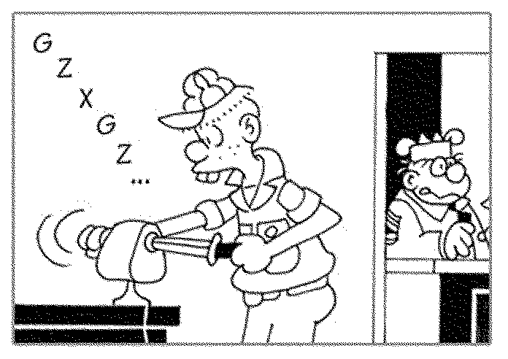
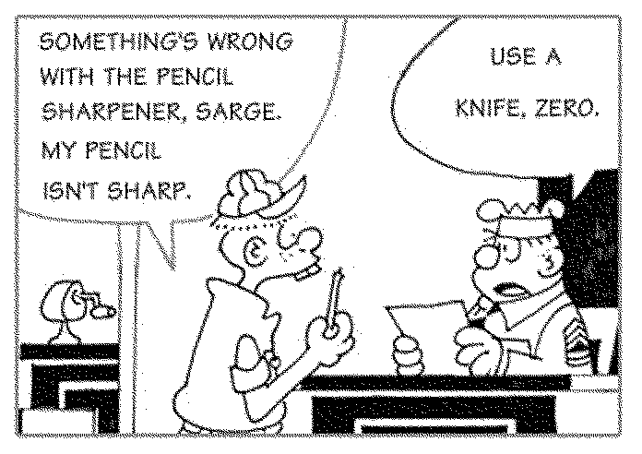

9. From the cartoon above, you can make a conclusion that .................................... .
1) Zero is stupid 2) Zero is joking
3) the pen is not good 4) the sharpener is blunt


10.

If you want to get the job, you would .................................... .
1) see the manager 2) go to the office
3) phone the office 4) write to the office
FIRE INSTRUCTIONS
THE PERSON DISCOVERING A FIRE WILL:
1. OPERATE THE NEAREST FIRE ALARM. (This will cause the Alarm Bells to ring, and also send a signal to the telephone switchboard operator who will immediately call the Fire Brigade).
2. ATTACK THE FIRE WITH AVAILABLE EQUIPMENT, IF IT IS SAFE TO DO SO.
FIRE ALARM BELLS
The Fire Alarm Bells will ring either in the area of A Block (Workshops and Administration Offices) or in the area of B Block (Teaching) and C Block (Sports Hall). Those in the area where the Alarm Bells are ringing should take action as indicated below. Others should continue with their work.
ON HEARING YOUR FIRE ALARM:
1. Those in class : will go to the Assembly Area under instructions given
by teacher
2. Those elsewhere : will go to the Assembly Area by the most sensible route,
and stay near the Head of their Department

ASSEMBLY AREA
The Assembly Area is the playing field which is south of the Sports Hall.
Here names will be checked.
PROCEDURE
1. Move quietly.
2. Do NOT stop to collect your personal belongings.
3. Do NOT attempt to pass others on your way to the Assembly Area.
4. Do NOT use the lift.
FIRE ALARMS
Fire Alarms are situated as follows:-
1. Administrative Block
At the Reception Desk; at east end of connecting corridor; outside
the kitchen door; back of the stage in the Maxin Hall.
2. Teaching Blocks
At the bottom of both stairways and on each landing.
3. Workshops
Outside Machine Shop No.1; Engineering Machine Shop No. 2.
4. Sports Hall
Inside entrance lobby.
11. This passage consists of advice on fire safety for .................................... .
1) students at school
2) students at college
3) workers in an engineering factory
4) people using a new kind of equipment
12. When a person discovers a fire, the first thing he should do is .................................... .
1) to telephone the switchboard operator
2) to start the alarm bells ringing
3) to contact the fire brigade
4) to attempt to put it out himself
13. Everyone in the block where the fire bell has rung must gather for a check of
names .................................... .
1) in the administration offices 2) in another block
3) in the sports hall 4) in the playing field
14. Imagine you are a secretary in the administration office, when a fire breaks out in
the sports hall. You should .................................... .
1) go to the assembly area quickly
2) carry on with the work you are doing
3) go to the director
4) look for the fire-fighting equipment
15. Imagine you are a teacher. Your first duty in case of fire is .................................... .
1) to lead your students out of the building
2) to check the names of your students
3) to patrol the stairways and landings
4) to get detailed instructions from your Head of Department
พิจารณาข้อความที่กำหนดให้แล้วเลือกหัวข้อเรื่องที่เหมาะสม (ข้อ 16-20)
16. Three small children are saved from a burning house.
1) Blaze Killed Three Children.
2) Bully Bird Saved Three Children.
3) Blaze in Bin.
4) Three Are Saved from Choking Smoke.
17. Police are looking for the owners of stolen goods.
1) Any of This Loot Yours. 2) Handbag Snatch.
3) £300 in Pub Para-Leap. 4) Bored Boy Broke into Workshop.
18. A small fire breaks out at a local school.
1) Island Holiday Ends in Death.
2) Three Are Saved from Choking Smoke.
3) Blaze in Bin.
4) Bored Boy Broke into Workshop.
19. A girl was knocked off her bike by a car.
1) Man Hurt in Road Mishap. 2) Cyclist Hunt in Collision.
3) Pedal Power Pays. 4) Skullduggery!
20. Girls and boys from a local school go on a sponsored bike ride.
1) Handbag Charity. 2) £300 in Pub Para-Leap.
3) Pedal Power Pays. 4) Money Talks.

777777777777777777777777777777777777777777777777

